Name: Rena

8-year-old. Energetic girl. Please refer to the voice in the video.

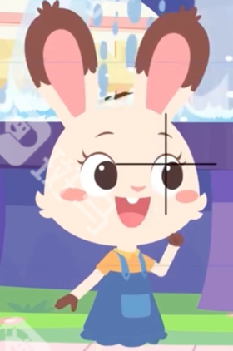

Audition part:

I want to be a photographer.

Whoa!

Wow!

It's a dolphin!

My dream is to take pictures of animals.

I love sports.

Patty doesn’t like sports.

But she always cheers for me at ma game.

We like different things, but we are still best friends.