Name: Patty

8-year-old. Sweet and lovely. Please refer to the voice in the video.

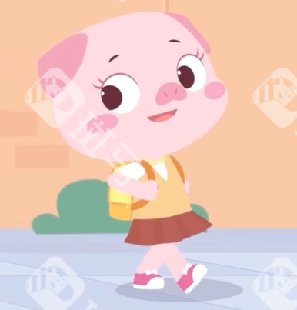

Audition part:

Tomorrow is my birthday.

I'm excited!

I want a violin for my birthday.

I just want a violin.

Well...

I want to be a teacher.

I know...

Thanks, guys!

What a fantastic birthday party!